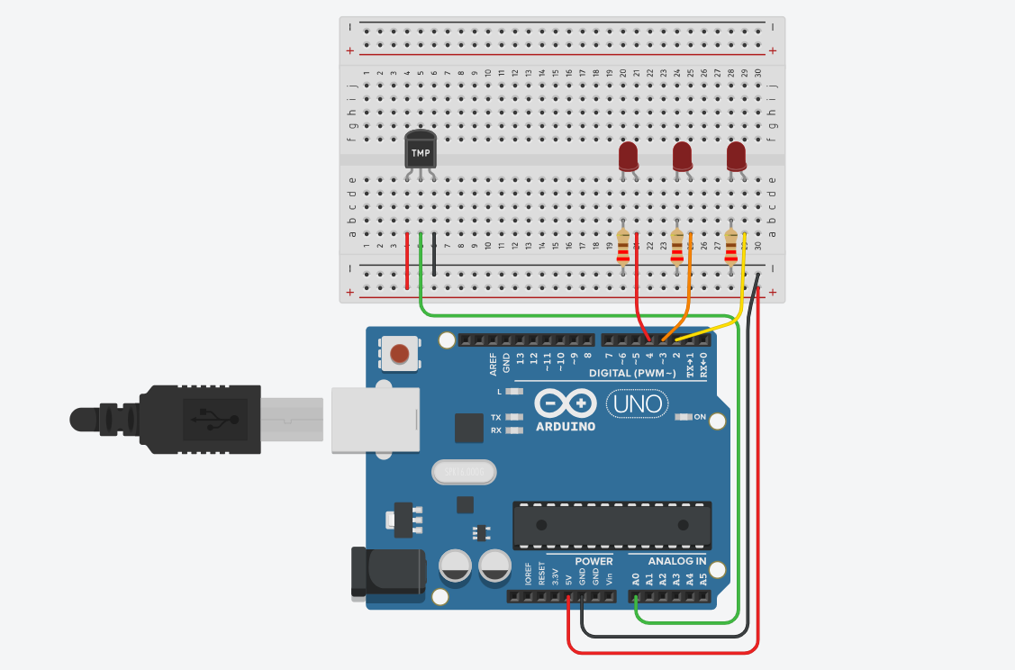

// C++ code
//
int baselineTemp = 0;

int celsius = 0;

int fahrenheit = 0;

void setup()
{
pinMode(A0, INPUT);
Serial.begin(9600);
pinMode(2, OUTPUT);
pinMode(3, OUTPUT);
pinMode(4, OUTPUT);
}

void loop()
{
// set threshold temperature to activate LEDs
baselineTemp = 40;
// measure temperature in Celsius
celsius = map(((analogRead(A0) - 20) * 3.04), 0, 1023, -40, 125);
// convert to Fahrenheit
fahrenheit = ((celsius * 9) / 5 + 32);
Serial.print(celsius);
Serial.print(" C, ");
Serial.print(fahrenheit);
Serial.println(" F");
if (celsius < baselineTemp) {
digitalWrite(2, LOW);
digitalWrite(3, LOW);
digitalWrite(4, LOW);
}
if (celsius >= baselineTemp && celsius < baselineTemp + 10) {
digitalWrite(2, HIGH);
digitalWrite(3, LOW);
digitalWrite(4, LOW);
}
if (celsius >= baselineTemp + 10 && celsius < baselineTemp + 20) {
digitalWrite(2, HIGH);
digitalWrite(3, HIGH);
digitalWrite(4, LOW);
}
if (celsius >= baselineTemp + 20 && celsius < baselineTemp + 30) {
digitalWrite(2, HIGH);
digitalWrite(3, HIGH);
digitalWrite(4, HIGH);
}
if (celsius >= baselineTemp + 30) {
digitalWrite(2, HIGH);
digitalWrite(3, HIGH);
digitalWrite(4, HIGH);
}
delay(1000); // Wait for 1000 millisecond(s)
}

Conclusion
This experiment helped me understand how temperature sensing works using digital components.
I learned to connect the sensors, read temperature values, and observe how the circuit responds to
Changes.

